PA5 report

Seungjin Kim

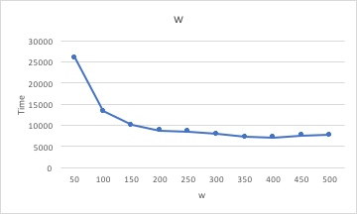

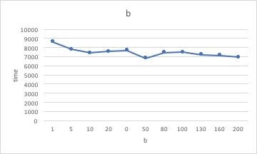

Compared to PA4, it is little bit slower because while PA4 use a lot of threads, in PA5, we were required to use only one thread called event handler that could replace all the working thread. However, having similar running time using one thread is big win.